|  |  |
| --- | --- |
| Course | Advanced Software Design – CS525 |
| Assignment | Lab 10 |
| Week | 13 |
| Due | Apr 27, 2020 |
| Student name | Quan Hong Doan |
| Student ID | 986956 |

Online version:

<https://github.com/zithiat/asd/blob/master/labs%20%26%20assignments/Answers/Assignment_CS525_Lab10_986956.docx>

**Problem**:

Problem is the question of LMS Framework design from the PDF file.

**Answer**:

LMS Framework

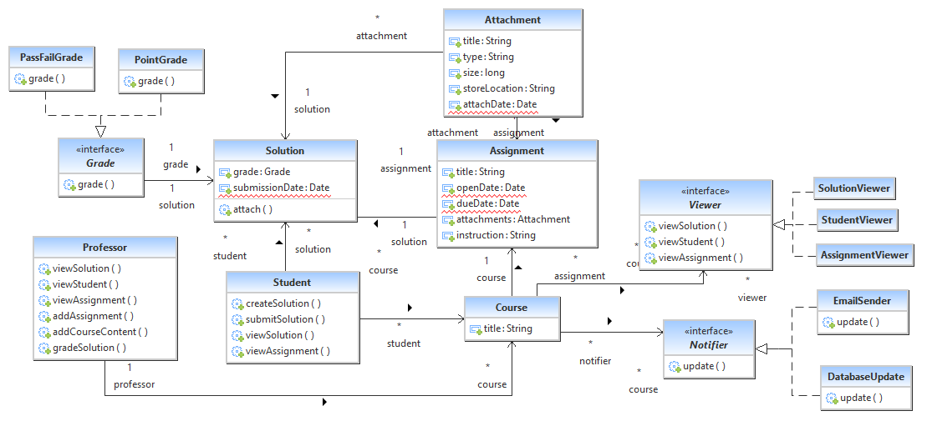

The hotspots for this LMS Framework are:

* Grade: we can add different ways for grading like %, ABCD scale
* Viewer: CourseViewer, or ProfessorViewer, etc. are additional.
* Notifier: we can add different notifiers here like SMS for the course assignment releases, grading updates, etc.

Those are external from the framework.

**Problem**:

Problem is the question of Racing Game Framework design from the PDF file.

**Answer**:

Racing Framework

Class diagram

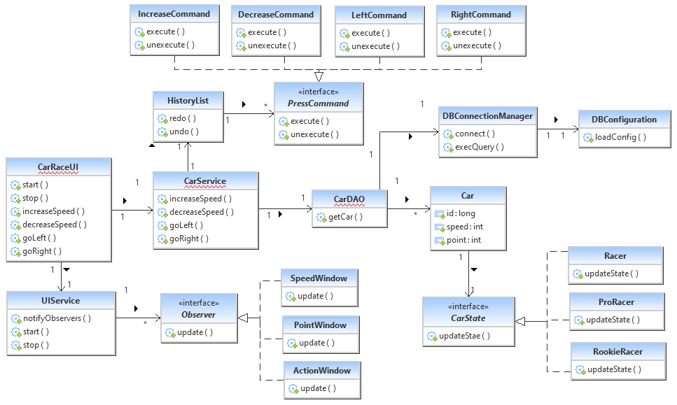

Those Observer, CarState, PressCommand interfaces are the hotspots of this framework.